# Introduction to Computer Science and Programming 1

### Quiz 1 (Chapter 1,2)

**Note:** This document has been designed and developed as part of an initiative for creating an OER (Open Education Resource) package for the course CSCI 120 at Columbia College.

Please contact [Alireza.davoodi@gmail.com](mailto:Alireza.davoodi@gmail.com) for any comment, modification, and questions.

**Terms of use:** Please feel free to customize this document as needed

Last Modified: May 2022

# Requirements

* Duration 15 min
* This is an individual quiz.
* Please do not talk to each other
* The order of the questions might be different for each student.
* Enter your answer in the answer sheet provided to you.

# Problem1

* Which statement is not correct about Python?

1. Python is a case-sensitive language
2. Data types in Python is associated to the variables.
3. Int, Float, Boolean are examples of data types in Python
4. You can change the value of the constant in Python with no compile error.

# Problem2

* Which statement is correct

1. A = 10 b=”20” print(“%d %s” \ (a+b))
2. A = 10 b=”20” print(“%s” \ (a+b))
3. A = 10 b=”20” print(“%d” \ (a+b))
4. None of the them

# Problem3

* What does this flowchart do?

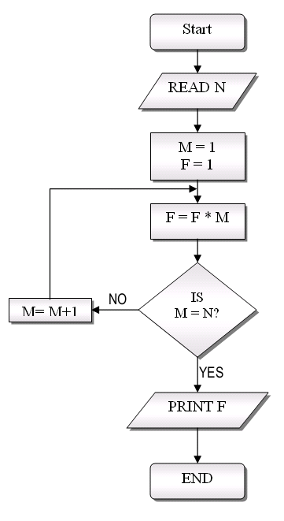

1. Calculates M to the power of N
2. Calculates N to the power of M
3. Calculate M*N
4. None of the them

# Problem4

* What is the result of above flowchart for the input N=4

1. The output depends on N
2. 4
3. 12
4. 24

# Problem5

* Which statement makes sure the input from the user is valid for this specific question? Imagine:

userInput = input(“Please enter your monthly salary”)

1. userInput.isdigit() and int(userInput)>0
2. int(userInput)!=0 and int(userInput)>0
3. userInput.isdigit() and userInput.isalnum()
4. All of the above

**Good Luck ☺**